ElastiCache – Cache Security
- ElastiCache supports IAM Authentication for Redis
- IAM policies on ElastiCache only used for AWS API-level security
- Redis AUTH:
  - You can set password/token when create a Redis cluster
  - This is extra level of security for your cache (on top of security groups for inbound/outbound traffic rules)
  - Support SSL in-flight encryption
- Memcache: Support SASL based authentication (advance)
Pattern for ElastiCache:
- Lazy Loading: all the read data is cached, data can become stale in cache
- Write through: Adds or update data in the cache when written to a DB (no stale data)
- Session Store: store temporary session data in a cache(using TTL features)
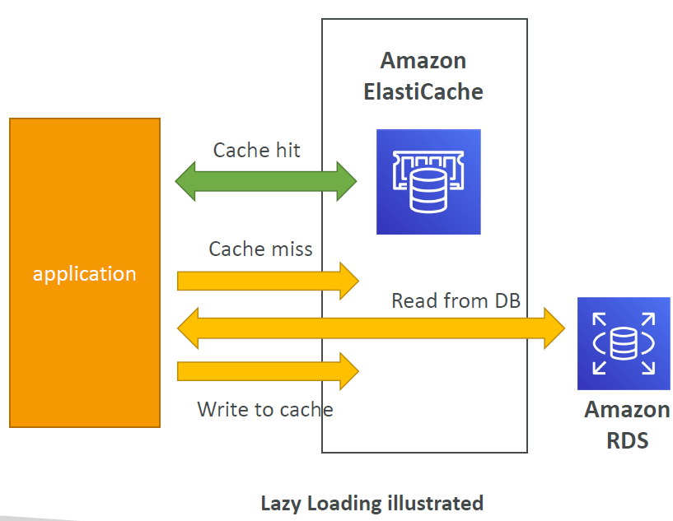
Important list or Ports to be familiar with:
(HTTPS - port 443) and a database port (PostgreSQL - port 5432)
Important ports:
- FTP: 21
- SSH: 22
- SFTP: 22 (same as SSH)
- HTTP: 80
- HTTPS: 443
vs RDS Databases ports:
- PostgreSQL: 5432
- MySQL: 3306
- Oracle RDS: 1521
- MSSQL Server: 1433
- MariaDB: 3306 (same as MySQL)
- Aurora: 5432 (if PostgreSQL compatible) or 3306 (if MySQL compatible)

QA
Question 1:
Amazon RDS supports the following databases, EXCEPT:
Answer: MongoDB it is obvious that MongoDB is a non-sequel database and RDS stand for Relation Database
Explain: RDS supports MySQL, PostgreSQL, MariaDB, Oracle, MS SQL Server, and Amazon Aurora.
Question 2:
You're planning for a new solution that requires a MySQL database that must be available even in case of a disaster in one of the Availability Zones. What should you use?
Answer: Enable Multi-AZ; Explain: Multi-AZ helps when you plan a disaster recovery for an entire AZ going down. If you plan against an entire AWS Region going down, you should use backups and replication across AWS Regions.
Question 3:
We have an RDS database that struggles to keep up with the demand of requests from our website. Our million users mostly read news, and we don't post news very often. Which solution is NOT adapted to this problem?
Answer: RDS Multi-AZ
Explain: Enable RDS Multi-AZ for disaster recovery and make RDS available in more than 1 AZ not to enhance the query speed of RDS

Question 4:
You have set up read replicas on your RDS database, but users are complaining that upon updating their social media posts, they do not see their updated posts right away. What is a possible cause for this?
Answer: Replication is ASYNC so reads are eventually consistent (means that in a distributed database system, data is not immediately synchronized across all replicas or nodes after an update but will reach consistency over time)
Consistent = even = persistent mean that an app will eventually update the data being display on the web interface synchronously with the updated database data.
Question 5:
Which RDS (NOT Aurora) feature when used does not require you to change the SQL connection string?
Answer: Multi-AZ
Question 6:
Your application running on a fleet of EC2 instances managed by an Auto Scaling Group behind an Application Load Balancer. Users have to constantly log back in and you don't want to enable Sticky Sessions on your ALB as you fear it will overload some EC2 instances. What should you do?
Answer: Storing Session Data in ElastiCache is a common pattern to ensuring different EC2 instances can retrieve your user's state if needed.
Question 7:
An analytics application is currently performing its queries against your main production RDS database. These queries run at any time of the day and slow down the RDS database which impacts your users' experience. What should you do to improve the users' experience?
Answer: Setup a Read replica

Question 8:
You would like to ensure you have a replica of your database available in another AWS Region if a disaster happens to your main AWS Region. Which database do you recommend to implement this easily?
Note: Multi-AZ won’t be able to recover your DB when disaster happens on Region level since it only recover across Availability Zones in the same region like ap-southeast (South East Asia)
Answer: Aurora Global Databases allows you to have an Aurora Replica in another AWS Region, with up to 5 secondary regions.
Question 9:
How can you enhance the security of your ElastiCache Redis Cluster by allowing users to access your ElastiCache Redis Cluster using their IAM Identities (e.g., Users, Roles)?
Answer: Using IAM Authentication
Question 10:
Your company has a production Node.js application that is using RDS MySQL 5.6 as its database. A new application programmed in Java will perform some heavy analytics workload to create a dashboard on a regular hourly basis. What is the most cost-effective solution you can implement to minimize disruption for the main application?
Answer: Create a Read Replica in a different AZ and run the analytics workload on the replica DB
Question 11:
You would like to create a disaster recovery strategy for your RDS PostgreSQL database so that in case of a regional outage the database can be quickly made available for both read and write workloads in another AWS Region. The DR database must be highly available. What do you recommend?
Answer: Create a Read Replica in a different region and enable Multi-AZ on the Read Replica

Question 12:
You have migrated the MySQL database from on-premises to RDS. You have a lot of applications and developers interacting with your database. Each developer has an IAM user in the company's AWS account. What is a suitable approach to give access to developers to the MySQL RDS DB instance instead of creating a DB user for each one?
Answer: Enable IAM Database Authentication
Reference to explanation: https://aws.amazon.com/blogs/database/iam-authentication-with-amazon-rds-for-mariadb/
Question 13:
Which of the following statement is true regarding replication in both RDS Read Replicas and Multi-AZ?
Answer: Read replica uses Asynchronous replication and Multi-AZ uses Synchronous Replication
Question 14:
How do you encrypt an unencrypted RDS DB instance?
Answer: Create a snapshot of the unencrypted RDS DB instance, copy the snapshot and tick “Enable encryption”, then restore the RDS DB instance from the encrypted snapshot
Question 15:
For your RDS database, you can have up to 15 replicas Read Replicas.
Question 16:
Which RDS database technology does NOT support IAM Database Authentication?
Answer: Oracle SQL doesn’t support IAM Authentication by AWS
Question 17:
You have an un-encrypted RDS DB instance and you want to create Read Replicas. Can you configure the RDS Read Replicas to be encrypted?
Answer: No. You must encrypt RDS and Read Replicas at define stage.
Question 18:
An application running in production is using an Aurora Cluster as its database. Your development team would like to run a version of the application in a scaled-down application with the ability to perform some heavy workload on a need-basis. Most of the time, the application will be unused. Your CIO has tasked you with helping the team to achieve this while minimizing costs. What do you suggest?
Answer: Aurora Serverless
Explain: • Automated database Client instantiation and auto-scaling based on actual usage
• Good for infrequent, intermittent or unpredictable workloads
• No capacity planning needed
• Pay per second, can be more cost-effective

Question 19:
How many Aurora Read Replicas can you have in a single Aurora DB Cluster?
Answer: From 1 and up to 15 Read replicas in a single Aurora DB Cluster

Question 20:
Amazon Aurora supports both MySQL and PostgreSQL databases.
Question 21:
You work as a Solutions Architect for a gaming company. One of the games mandates that players are ranked in real-time based on their score. Your boss asked you to design then implement an effective and highly available solution to create a gaming leaderboard. What should you use?
Answer: Use ElastiCache for Redis – Sorted Set
Explain: ElastiCache will store frequently access data in it cache which drastically reduce query time and workloads and Sorted Sets will sort the data to update the player’s ranked in real-time before it save new ranked list into ElastiCache
Question 22:
You need full customization of an Oracle Database on AWS. You would like to benefit from using the AWS services. What do you recommend?
Answer: RDS Custom for Oracle

Question 23:
You need to store long-term backups for your Aurora database for disaster recovery and audit purposes. What do you recommend?
Answer: Perform On Demand Backups also known as Manual snapshot triggered by user at any time to backup Aurora DB.
Question 24:
Your development team would like to perform a suite of read and write tests against your production Aurora database because they need access to production data as soon as possible. What do you advise?
Answer: Use Aurora Cloning feature
Explain: It much faster than snapshot a DB and suitable for switching to different stage like from Production to Test stage for different purposes
Question 25:
You have 100 EC2 instances connected to your RDS database and you see that upon a maintenance of the database, all your applications take a lot of time to reconnect to RDS, due to poor application logic. How do you improve this?
Answer: Use RDS Proxy
Explain: RDS Proxy will keeps the connection activities for your applications rather than do a reconnect frequently which can avoid failover due to such a large 100 EC2 connections to RDS at the same time. It also reduce the failover time by up to 66%.

